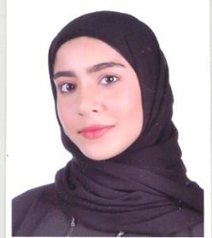

I would like to get a job in this area, entice customers attraction and retention and maintaining a healthy cash flow. Acquisition more experience and skills to benefit me in my field and also benefit your company.

* **Arabic     **
* **English     **
* **Basketball**
* **Movies**

***Objective:***

***Interest and hobbies:***

***Languages:***

**Computer skills Communication skills**

**Hard working Work under pressure**

***Personal Skills:***

* **Training course as accountant assistant at American Mission Hospital**
* **Selling goods on Instagram**

***Personal Information:***

***Experience:***

* **Student in University of Bahrain, Major: Accounting**
* **Scholarship from Ministry of Education**
* **Secondary School Certificate**
* **Certificate of participation in GPIC**

Making a device that serves the environment

* **English language certificate**

Twin group UK & British council

***Education Reference:***

**Address:** Bahrain, Manama

**Nationality:** Bahraini

**Mobile:** 33032904

**Email:** [maaram.m10@gmail.com](mailto:maaram.m10@gmail.com)

Maram Mohamed Ali